1. Big Buildings?  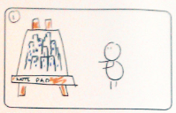  interaction: none  graphics: easel/note pad, sky scraper images  sound: (MUSIC STARTS AT BEGINNING) | 2. But why big? Why can't they be normal?  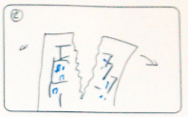  interaction: image ripped in 2  graphics:as 1  sound: ripping | 3. Is it old? Is it new?  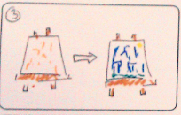  interaction: hands distance fades from sepia to colour image  graphics: as 1&2 plus sepia version of same  sound: super8 projector into modern sound / pin?
4. How big would this city be? Small, large?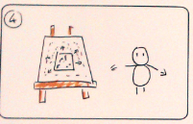  interaction: shrink and grow image  graphics: as 1  sound: pitch goes as stretched, not cartoony, creaking rope being overstretched, rope bridge | 5. Is everything within it self? Or all together? 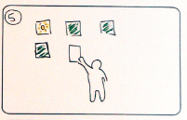  interaction: playing cards appear face down in the background. when the performer places a hand over them, they turn over and then back again.  graphics: playing card front and rear  sound: card flicking/whoosh | 6. Why is it interesting? Who should live there? Why should anyone live there? What if its all a dream? Can it be believable? Can this be what people want? Is it economic? Do we have solar panels? What if it's never sunny? What about waternomics?’  interaction: performer flicks through  graphics: images representing each idea  sound: ?

